**Experiment: Single Phase AC Series Circuit**

**Objectives:** To determine experimentally;

**(1)** Voltage distribution in a single phase AC series circuit.

**(2)** Power and power factor of the (a) circuit (b) choke coil.

**(3)** The value of the circuit elements R, L &C

**Equipments: (1)** Resistor **(2)** Choke coil **(3)** Capacitor **(4)** SPDT Key

**(5)** Wattmeter 250V/1Amp **(6)** AC volt-meter150V **(7)** AC Ammeter- 1Amp

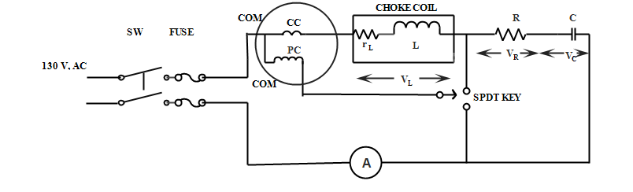

**Circuit Diagram**

**Theory:**

For a given AC series circuit, when energized from an ac source, same current flows through series connected resistance R, choke coil L& capacitor C.

The voltage drop across these elements is as follows:

**(1)**Across Resistance;**VR = IR**

**(2)** Across Inductance; **VL=IXL= I(jωL)**

**(3)** Across Capacitor;**Vc= -jIXC=I/(jωc)**

**(4)** The resistance of inductance rL can be measured by multimeter,so total circuit resistance =**(R + rL)**

**(5)** Total voltage across the circuit is : **VS  = I[R+rL+j(ωL-1/ωC ) ] = I [ R+rL+j (XL – Xc ) ]**

**= I (R+rL+jX)=IZ**

**(6)** Power consumed in the choke coil = **PL=I2(rL)=VLICosФ**

**(7)** Power factor of the circuit **CosФ =( R + rL ) /Z**

**(8)** Power consumed in the circuit, **Pt = I2 (R + rL ) = VsICosФ** (the extra power I2rL is consumed by choke coil)

**(9)** Power factor of the choke coil = **rL/√ rL2 + X2 = PL / VLI**

Where

XL = ωL; Inductive reactance in ohms; XC = (1/ωc); Capacitive Reactance in ohms;

ω =2πf in radians (f is frequency in HZ) ; X= XL –XC , the combined reactance in ohms

Now, impendence Z = √ {( R + rL)2 + X2 }

**Procedure:**

* Connect the experimental set as shown in the circuit diagram.
* Select AC 130volt from the supply panel and switch on the input supply.
* Measure voltage drop across each component with the help of voltmeter.
* Measure current flowing in the circuit with the help of ammeter.
* Keep SPDT switch at position 1, Wattmeter will give the power consumed (PL) in the choke coil.
* Shift SPDT switchto position 2, wattmeter will give the power consumed (Pt) by the total circuit.
* Record the readings of the instruments carefully in the observation table.

**Precautions:**

* Always keep the measuring instruments in horizontal position.
* Select appropriate range of the instruments i.e the range of the instruments should always be more than the existing value of current or voltage in the circuit .
* Do not touch the resistance as it might have been heated up.

**Observation Table:**

|  |  |  |  |  |  |  |  |
| --- | --- | --- | --- | --- | --- | --- | --- |
| **Sr. No**. | **Applied voltage** | **Circuit current** | **Voltage drop across circuit elements** | | | **Power consumed (W)** | |
| **VS** | **I** | **Resistance**  **VR** | **Choke coil**  **VL** | **Capacitor**  **VC** | **Across choke coil**  **PL** | **Whole circuit**  **Pt** |
| **1.** | 132V | 0.5A | 96V | 38V | 94V |  |  |

**Report:**

* Using the relations given in theory, calculate the following for supply voltage;Impedance of coil ZL , Inductive reactance of coil XL , Capacitive reactance XC and hence R, L & C.
* Calculate the value of power and power factor of the total circuit and that of choke coil.Compare these values with the wattmeter readings.
* Draw the phasor diagram for any one of the observations.
* Draw the waveform for voltage and current in the RL series circuit as a function of time.

**Points to remember:**

1. Multiplication factor of wattmeter =(Voltage range*Current range*pf of wattmeter)/Max scale deflection.
2. Actual reading of wattmeter = multiplication factor * reading of wattmeter.